5 Checking Normal with Face Orientation
10/5/2026

What Are Normals?
Normals determine which side of a face is considered outside and which side is inside.
In Blender 5, the easiest way to visualize normals is by using the Face Orientation display.

How to turn on Normals
Go to Viewport Overlay’s tab located at the top left of viewport.
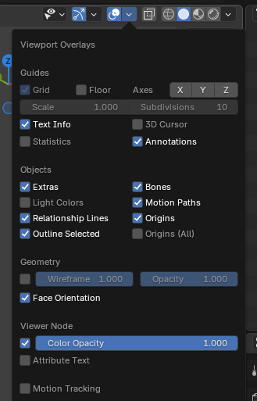

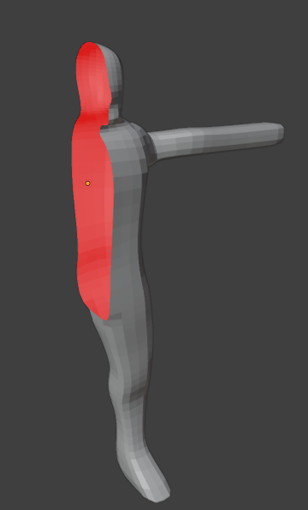

Outside normals will show as gray. Only the inside normals will show up as red.

How Fix broken Normals.
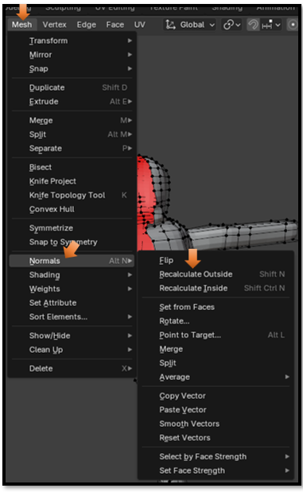

I found a small sliver of flipped normals. It was so small I barely noticed it.
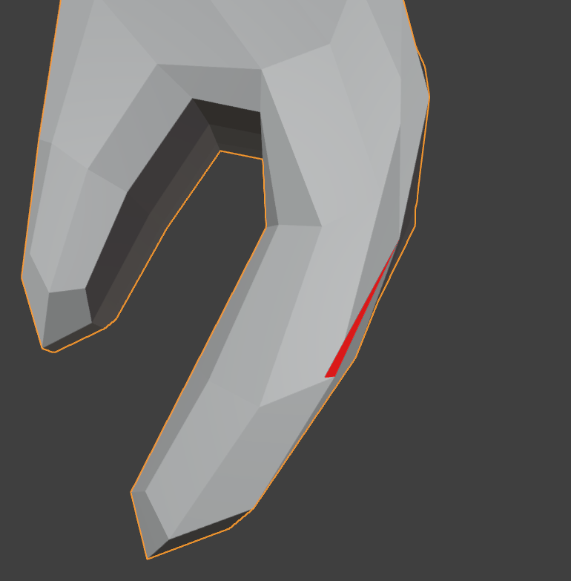

Step 1 — Recalculate the Entire Mesh
This is the first thing I would do.
- Go into Edit Mode.
- Press A to select everything.
- Press Shift + N (Recalculate Outside).
Now look again.

If the red disappears...
Fantastic.
You're done.

